Project Design Phase-II
Data Flow Diagram & User Stories

Date | 31 January 2025
Team ID | Not specified in project brief
Project Name | Auto Ticket Classification using Flow Designer
Maximum Marks | 4 Marks

Data Flow Diagram: School IT Ticket Classification
This DFD shows how a school IT support request moves from the caller through Flow Designer keyword evaluation into a structured Incident Workflow record and an email acknowledgement.
Example: DFD Level 0 (Industry Standard)
Project data flow and user stories
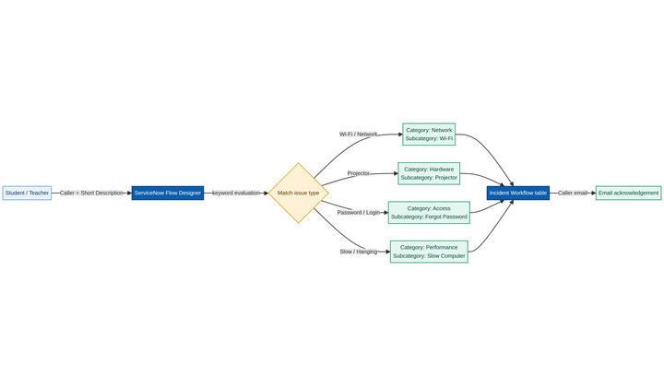

User Stories
The following stories translate the project requirements into testable work items for the school IT helpdesk automation.
User Type | Functional Requirement (Epic) | User Story Number | User Story / Task | Acceptance criteria | Priority | Release
Student / Teacher | Ticket intake | USN-1 | As a student or teacher, I can submit my Caller and Short Description so an IT ticket is created. | A record is created in Incident Workflow with an auto-number. | High | Release 1
Student / Teacher | Classification | USN-2 | As a student or teacher, I can describe a Wi-Fi, projector, password, or slow-computer issue in plain language. | Flow Designer identifies the keyword and assigns the expected Category and Subcategory. | High | Release 1
IT Helpdesk Agent | Routing | USN-3 | As an IT agent, I can see standardized Category, Subcategory, State, Assigned Group, and Assigned to values. | The record contains consistent choice and reference data for routing. | High | Release 1
IT Helpdesk Agent | Dependent choices | USN-4 | As an IT agent, I can use Category-dependent Subcategory values. | Only valid mappings are available: Network/Wi-Fi, Hardware/Projector, Access/Forgot Password, Performance/Slow Computer. | High | Release 1
Student / Teacher | Notification | USN-5 | As a caller, I receive an email after my request is submitted. | Email is sent to Caller → Email with a ticket confirmation subject and body. | Medium | Release 1
Administrator | Configuration | USN-6 | As an administrator, I can maintain the no-code Flow Designer conditions and update set. | The flow is active, the Project Update Set captures changes, and XML export is available. | Medium | Release 2
IT Helpdesk Agent | Validation | USN-7 | As a tester, I can verify Wi-Fi and Projector scenarios end to end. | Category, Subcategory, and email results match the configured keyword rules. | High | Release 1
Customer Care Executive
Administrator

